**The CSU Chancellor’s Office Community-Engaged Learning Initiative**

**Faculty Frequently Asked Questions**

**Table of Contents**

|  |  |
| --- | --- |
| **What is this initiative about?** | What is the Community-Engaged-Learning (CEL) Initiative about?  How are the Community-Engaged Learning (CEL) attributes being applied?  What does it mean if a course receives one attribute of the other?  What courses are included? |
| **Why is this initiative important?** | Besides being “required” by the Chancellor’s Office, are there any benefits to this process?  Why is the CEL attribute process important? How does it benefit me as a faculty member?  What happens with all this data? |
| **How does this process work?** | How frequently will faculty be asked to complete the CELT?  What if faculty don’t think their courses should be included?  Faculty just don’t have time for “one more thing.” How long does the CELT take?  When in the term should faculty complete the CELT?  What happens after a faculty member completes the CELT?  What if a faculty member disagrees with the attribute received?  What if a campus has a formal definition for service learning or a course designation process?  What if a campus already collects course information and syllabi from faculty as part of policy or an “S” designation process?  The community learning activity is a required part of the course, but occasionally a student may need an accommodation or because of COVID-19, all students are provided an option. In this case, should the faculty member indicate required or optional in the course information? |

### What is the Community-Engaged-Learning (CEL) Initiative about?

### The Chancellor’s Office (CO) is looking to align a systemwide understanding of community-engaged learning (CEL) courses across the CSU. The purpose is to improve data collection to better support faculty and understand student learning, faculty efforts, and community impact. To do this, the CO has implemented two course attributesi: CCEL (Curricular Community-Engaged Learning – to refer to a broad array of courses that have some type of community engaged assignment) built around reciprocal partnerships that enhance student understanding, the outcomes of which benefit the common good, and CSLI (Community Service Learning – to refer to a distinct pedagogy that intentionally and explicitly integrates course learning, civic learning, community learning activities, and community partners). [Learn more](https://docs.google.com/document/d/1TFLPr4sy6pYOQLadtn7uxjowO6C20tkO6qw__Y-bPi0/edit).

### 

### How are the Community-Engaged Learning (CEL) attributes being applied?

The attributes are applied in the student information system and based on a CEL Tool (CELT) that asks faculty about their teaching and community partnershipii practices. The CELT is based on a [course taxonomy for community- engaged learning](https://drive.google.com/file/d/1YYGOnxzl6zrRWlBO2I5p-tYt6vD7FGDN/view?usp=sharing) which outlines the essential elements of these types of courses within a spectrum of implementation practices. Faculty complete a separate CELT for each course and the attribute is applied based on the faculty member’s responses.

### 

### What does it mean if a course receives one attribute versus the other?

Both Curricular Community-Engaged Learning and Service Learning are valuable learning tools for students. The difference is in implementation of the community-engaged learning activity and the approach to the community partnership. This effort is about data collection to better understand student learning, faculty efforts, and community impact so that as a system we can 1) better support faculty and community partners; and 2) improve evidence-based research of community-engaged learning experiences on student success and its impact on faculty scholarship. The information will lead to more accurate and easier course reporting and offers the potential for scholarship around community-engaged teaching. SL/CE offices will also be planning on how best to use the information for their campuses.

### What courses are included?

Each campus has traditionally identified curricular community-engaged and service-learning (SL) courses independently. This effort will look at both types of courses. Courses will include a wide variety of departments and course models.

### How frequently will faculty be asked to complete the CELT?

Based on faculty feedback following the 20/21 AY CELT pilot implementation, the Chancellor’s Office determined the following: 1) Faculty will need to complete a separate CELT for each CEL course they teach. 2) The CELT should be completed at a minimum of every five years, but it may also be completed anytime there is a significant course change (i.e., new CEL course developed, significant revisions to the CEL course or change in faculty member teaching the CEL course).

### What if faculty don’t think their courses should be included?

It is important for faculty who have committed to teaching community-engaged learning courses to complete the CEL Tool. Please see questions 3, 9 and 16 for why this is important.

### Faculty just don’t have time for “one more thing.” How long does the CELT take?

For those who review the CEL Taxonomy ahead of time and have access to course information, the CEL Tool should take between 15-20 minutes to complete and consists of questions faculty would easily be able to answer for a course they are teaching.

### When in the term should faculty complete the CELT?

Each campus SL/CE office has identified a calendar for completion based on campus scheduling policies and procedures, faculty assignment notifications, and other academic policies. The Chancellor’s Office strongly recommends that, when possible, faculty with known course assignments complete the CELT the term prior to the term the course is taught. This will support department schedulers, the registrar’s office and the SL/CE office in ensuring courses are accurately identified in the course management system.

### Why is the CEL attribute process important? How does it benefit me as a faculty member?

Faculty-identified benefits from a pilot conducted at 7 campuses in February 2020 of the CEL Tool indicate that faculty found the CELT to be most beneficial in better understanding student learning, the essential elements of the community-engaged learning spectrum and insights into curriculum preparation and design. (figure 1)

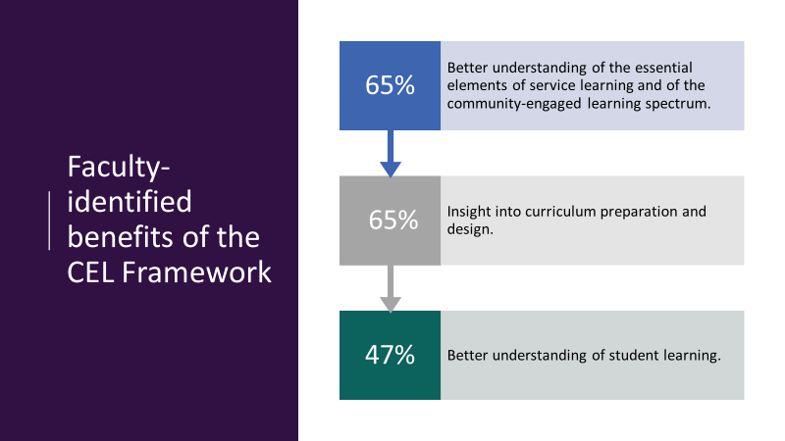

CSU faculty quotes:

* *It would be beneficial for faculty to have this as they are prepping their course so they can create assignments, activities, evaluation criteria, and general structure of the course in doing so. I currently teach my CEL course, but will use this framework when prepping for next semester.*
* *Some of the survey questions would have helped me think more carefully about how I facilitate specific connections between course content and community projects.*
* *I think having the rubric [taxonomy] gave some guidance and helped me to evaluate places where I could better collaborate with community partners (e.g., formation of reflections).*

Results from a three-year STEM service-learning (SL) research study conducted by the Chancellor’s Office underscored the importance of further evidence-based research on SL in three areas: the relationship between SL and student success, SL faculty development and the types and effectiveness of SL partnerships.

In this Michigan Journal of Community Service-Learning [article](https://quod.lib.umich.edu/cgi/t/text/text-idx?cc=mjcsloa;c=mjcsl;c=mjcsloa;idno=3239521.0026.201;view=text;rgn=main;xc=1;g=mjcslg), the authors of the CSU system study argue that as best practices in faculty development continue to emerge, it is imperative that institutions invest in properly prepared service-learning faculty as a strategy to meet student success goals (Botelho, et al., 2020). In their work on *Models and Genres of Faculty Development*, Gravett and Broscheid (2018) underscored the need for support units to cultivate relationships with faculty to effectively assist their learning in a multitude of interconnected areas that promote high-quality SL, including cultivating relationships with community partners, learning how to coach students through disorienting learning experiences, and assessing the effectiveness of SL experiences.

### What happens after a faculty member completes the CELT?

Both the faculty member and the service-learning/community-engagement (SL/CE) office will receive email notification of the CELT submission and the preliminary attribute identified. If more discussion is needed, the SL/CE office will reach out to the faculty member. Otherwise, the SL/CE office communicates with campus CMS staff to update the course attribute in the student information system.

### What if a faculty member disagrees with the attribute received?

Once a faculty member receives the results of the CELT, they may use this as an opportunity to connect with the campus SL/CE office. Because this effort is focused on a systemwide perspective, campus designations may differ slightly. The campus may decide what should happen in these cases by reviewing the CELT responses, the course taxonomy, and any campus policies or definitions.

### What happens with all this data?

The Office of the Chancellor will utilize the data to accurately identify the types and frequency of community engaged learning systemwide. The data will support the CSU to better measure the strength of service learning as a high impact practice and the information collected will enable the CSU to better support all forms of community engaged learning.

Representatives from each campus SL/CE office will review the data with campus partners to determine how they might find it useful. Some suggested ways are to formalize course identification processes on campuses where one does not exist; provide topics for faculty workshops and roundtable conversations about community engagement; identify faculty experts and provide topics for faculty or university research.

### 

### What if a campus has a formal definition for service learning or a course designation process?

This attribute process and CEL Tool does not supersede campus practices, but rather is complimentary of campus practices and definitions. It is meant to take a ‘bird’s eye view’ to align across the system. Campuses may still implement their own definitions and designation processes. Based on results, campuses may find it helpful to analyze data that brings to light inconsistencies. For example if a campus has an “S” or “SL” designated course but through the CELT, the course receives the CCEL attribute or “no attribute” – then it would be important for the faculty member and the SL/CE office to discuss the results.

### What if a campus already collects course information and syllabi from faculty as part of policy or an “S” designation process? Can someone else complete the CELT then?

Syllabi don’t necessarily provide the complete insight needed to respond to the CELT questions. The process has been designed to ensure faculty have a first-person voice in the application of the attributes; therefore, faculty are required to complete the CELT for their own courses

### The community learning activity is a required part of the course, but occasionally a student may need an accommodation or because of COVID-19, all students are provided an option. In this case, should the faculty member indicate required or optional in the course information?

If the community learning assignment is normally required, please indicate required. The “optional” flag is only meant for courses wherein the assignment is always optional for all students.

### Besides being “required” by the Chancellor’s Office, are there any benefits to this process?

Working from a common understanding will further the university’s identity as an “engaged institution,” contribute to quality transparent learning experiences for students, and offer opportunity for faculty dialogue and scholarship within and across disciplines.

Additionally, completing the CELT provides faculty with an opportunity to reflect on where they are and ways they can further improve and/or enhance their community-based teaching and strengthen their community partnerships.

See also **Why is the CEL attribute process important?** above for additional faculty benefits.

_____________________________

iAttributes are back-end notations in the student information system that provide additional course type information

iiCommunity Partners (entities, organizations, or groups with whom a relationship can be developed) in which students learn and develop through participation in the collaboration; the outcomes of which benefit the common good. Reciprocal community partnerships and processes shape the community-based activities and course design to enhance student understanding of the importance of community learning. Community-engaged learning experiences may include organized service activities, project- or place-based learning activities.

**Citations**

Botelho, J., Eddy, R., Galport, N., & Avila-Linn, C. (2020) Uncovering the Quality of STEM Service-Learning Course Implementation and Essential Elements Across the California State University System. *Michigan Journal of Community Service Learning*, 26, Issue 2, 1-20

Gravett, E. O., & Broscheid, A. (2018). Models and genres of faculty development. In B. Berkey, C. Meixner, P. M. Green, & E. A. Eddins (Eds.), *Reconceptualizing faculty development in service-learning/community engagement*. Stylus Publishing.